2nd Lt David Crow

ENG/20M

CSCE 531 Discrete Mathematics Fall 2018 Homework 5/6/7

Note: Most exercises are based on problems found in Rosen, but few are identical to those problems.

# Section 5.4

1. Devise a recursive algorithm to compute $x^{n}\operatorname{mod}{m}$ where $n,x,m∈Z^{+}$ based on the fact that

$x^{n}\operatorname{mod}{m} = \left(\left(x^{n-1} \operatorname{mod}{m}\right)\left( x \operatorname{mod}{m}\right)\right)\operatorname{mod}{m}$.

ComputeValue(x, n, m)

If n = 1:

Return (x mod m) mod m

Return (ComputeValue(x, n – 1, m) * (x mod m)) mod m

# Section 6.4

1. Show that if $n$ is a positive integer, then $\left({2n \atop 2}\right)=2\left({n \atop 2}\right)+n^{2}$
   * by using a combinatorial argument.

If we have $n$ fruits and $n$ vegetables, then we have $\left({2n \atop 2}\right)$ ways to select $2$ items. Alternatively, there are $\left({n \atop 2}\right)$ ways to select $2$ fruits, $\left({n \atop 2}\right)$ ways to select $2$ vegetables, and $n^{2}$ ways to select $1$ fruit and $1$ vegetable; in total, we have $2\left({n \atop 2}\right)+n^{2}$ ways to select $2$ items.

* + by algebraic manipulation.

Okay: $\left({2n \atop 2}\right)=\frac{\left(2n\right)!}{2!\left(2n-2\right)!}=\frac{2n\left(2n-1\right)\left(2n-2\right)!}{2\left(2n-2\right)!}=n\left(2n-1\right)=2n^{2}-n=n^{2}-n+n^{2}=n\left(n-1\right)+n^{2}$

$=\frac{n!}{\left(n-2\right)!}+n^{2}=2⋅\frac{n!}{2\left(n-2\right)!}+n^{2}=2\left({n \atop 2}\right)+n^{2}$.

# Section 6.5

1. How many different combinations of pennies, nickels, dimes, quarters, and half dollars can a piggy bank contain if it has $20$ coins in it? *Note: assume that all coins of a particular denomination are indistinguishable.*

Because the coins of a particular denomination are indistinguishable, and because order doesn’t matter (that is, $PNPPP..P≡NPPPP…P$), this is an $r$-combination. According to the book, there are $C(n+r-1, r)$

$r$-combinations from a set of $n$ elements when repetition is allowed.

Thus, there are $C\left(20+5-1, 5\right)=C(24, 20)$ possible combinations of coins.

# Section 7.1

1. Two events $E_{1}$ and $E_{2}$ are called independent if $p(E_{1}∩E_{2})=p(E_{1})p(E_{2})$. Suppose a fair coin is tossed three times. Determine whether each of the following pairs of events is independent. Justify your response.
   * $E_{1}$: the first coin comes up tails; $E_{2}$: the second coin comes up heads.

There are $\left|S\right|=\left|\left\{HHH,HHT,HTH,THH,TTH,THT,HTT,TTT\right\}\right|=8$ possible events. Thus,

$p\left(E_{1}\right)=\frac{4}{8}=\frac{1}{2}$, $p\left(E_{2}\right)=\frac{4}{8}=\frac{1}{2}$, $p\left(E_{1}\right)p\left(E_{2}\right)=\frac{1}{2}⋅\frac{1}{2}=\frac{1}{4}$, and $p\left(E_{1}∩E_{2}\right)=\frac{2}{8}=\frac{1}{4}$.

Because $p\left(E_{1}∩E_{2}\right)=\frac{1}{4}=p(E_{1})p(E_{2})$, we know $E_{1}$ and $E_{2}$ are independent.

* + : the first coin comes up tails; $E_{2}$: two, and not three, heads come up in a row.

Here, $p\left(E_{1}\right)=\frac{2}{8}=\frac{1}{4}$, $p\left(E_{2}\right)=\frac{2}{8}=\frac{1}{4}$, $p\left(E_{1}\right)p\left(E_{2}\right)=\frac{1}{4}⋅\frac{1}{4}=\frac{1}{16}$, and $p\left(E_{1}∩E_{2}\right)=\frac{1}{8}$. Because

$p\left(E_{1}∩E_{2}\right)=\frac{1}{16}≠\frac{1}{8}=p(E_{1})p(E_{2})$, we know $E_{1}$ and $E_{2}$ are not independent.

* + : the second coin comes up tails; $E_{2}$: two, and not three, heads come up in a row.

In this problem, $p\left(E_{1}\right)=\frac{4}{8}=\frac{1}{2}$, $p\left(E_{2}\right)=\frac{0}{8}=0$, $p\left(E_{1}\right)p\left(E_{2}\right)=\frac{1}{2}⋅0=0$, and $p\left(E_{1}∩E_{2}\right)=\frac{0}{8}=0$. Because $p\left(E_{1}∩E_{2}\right)=0=p(E_{1})p(E_{2})$, we know $E_{1}$ and $E_{2}$ are independent.

# Section 7.2

1. Suppose we randomly select a permutation of the 26 lowercase letters of the English alphabet. What are the probabilities of the following events?
   * a and z are next to each other in the permutation.

There are $26!$ possible permutations of this set.

We can treat “az” as a single lowercase letter. We now have 25 lowercase letters to permute, and, in each of these permutations, a and z are next to each other. This implies there are $25!$ events. Thus,

.

* + a and b are not next to each other in the permutation.

The probability of this event is the complement of the probability of the event in part a (which we’ll call $p(E_{a})$). Thus, .

* + z precedes both a and b in the permutation.

The positions of the other 23 letters don’t actually matter because each ordering of the letters $a$, $b$, and $z$ are equally likely. There are $\left|\left\{abz,azb,baz,bza,zab,zba\right\}\right|=6$ possible orderings of our three letters. Of these, $z$ precedes both $a$ and $b$ in two. Thus, the probability that $z$ precedes both $a$ and $b$ in a random permutation of the total set is $\frac{2}{6}=\frac{1}{3}$.

# Section 7.4

1. Suppose we flip a coin until either it comes up tails twice (not necessarily consecutively) or we have flipped it six times. What is the expected number of times we flip the coin?

Our expected number includes zero of two possible events for the first flip. It includes one of four possible events for the second flip. It includes two of eight for the third flip, three of 16 for the fourth flip, and four of 32 for the fifth flip.

We know that we stop after $n$ flips if a) the $n^{th}$ flip comes up tails and one other flip also came up tails, or b) we’ve flipped the coin six times. There are $n-1$ possible ways to satisfy (a) out of a total of $2^{n}$ possible events for a given $1<n<6$ (because the last flip must be tails and one of the first $n-1$ flips must also be tails). When $n=1$, the probability of reaching a stopping condition is $0$. When $n=6$, the probability of reaching a stopping condition is the probability of reaching the sixth flip (that is, the probability that we didn’t stop before the sixth flip). Here are the probabilities of stopping after $n$ flips, where $n$ ranges from $1$ to $6$:

$p\left(1\right)=0$, $p\left(2\right)=\frac{2-1}{2^{2}}=\frac{1}{4}$, $p\left(3\right)=\frac{3-1}{2^{3}}=\frac{2}{8}=\frac{1}{4}$,

$p\left(4\right)=\frac{4-1}{2^{4}}=\frac{3}{16}$, $p\left(5\right)=\frac{5-1}{2^{5}}=\frac{4}{32}=\frac{1}{8}$ $p\left(6\right)=1-0-\frac{1}{4}-\frac{1}{4}-\frac{3}{16}-\frac{1}{8}=\frac{3}{16}$

$∴E\left(x\right)=\sum_{s∈S}{x\left(s\right)p(s)}=\sum_{i=1}^{6}{i}⋅p\left(i\right)=1⋅0+2⋅\frac{1}{4}+3⋅\frac{1}{4}+4⋅\frac{3}{16}+5⋅\frac{1}{8}+6⋅\frac{3}{16}=3.75$ flips.=

# Section 8.1

1. Define a covering to be a particular arrangement of $1×2$ dominoes on a $2×n$ checkerboard such that every domino covers exactly two squares and every square is covered.
   * Find a recurrence relation for the number of coverings. [Hint: Consider separately the coverings where the position in the top right corner is covered by a domino positioned horizontally and where it is covered by a domino positioned vertically.]

There is $1$ way to tile a $2×0$ board.

There is $1$ way to tile a $2×1$ board.

There are 2 ways to tile a $2×2$ board.

There are 3 ways to tile a $2×3$ board.

There are $5$ ways to tile a $2×4$ board.

We can see that this is the Fibonacci sequence, so our recurrence is. .

* + What are the initial conditions for the recurrence relation in part (a)?

.

* + How many coverings are there for a $2×17$ checkerboard?

This is the same as the 17th Fibonacci number, which is 1597.

# Section 8.2

1. How many different messages can be transmitted in $n$ microseconds using $3$ different signals if

* the first signal requires $1$ microsecond to transmit,
* each of the other $2$ signals requires $2$ microseconds to transmit, and
* each signal other than the last is followed immediately by the next signal?

We can represent this with the recurrence relation $a_{n}=a_{n-1}+2a_{n-2}$ Here, $a_{1}=1$ and $a_{2}=3$. This gives us $r^{2}-r-2=0$, which in turn gives us $r=2$ and $r=-1$. Thus, $a_{n}=α_{1}{\left(-1\right)}^{n}+α_{2}{\left(2\right)}^{n}$.

$a_{1}=1=α_{1}{\left(-1\right)}^{1}+α_{2}{\left(2\right)}^{1}=-α_{1}+2α_{2}→α_{1}=2α_{2}-1$, so

$a_{2}=3=α_{1}{\left(-1\right)}^{2}+α_{2}{\left(2\right)}^{2}=α_{1}+4α_{2}=2α_{2}-1+4α_{2}→4=6α_{2}→α_{2}=\frac{2}{3}$.

This implies $α_{1}=2α_{2}-1=2\left(\frac{2}{3}\right)-1=\frac{4}{3}-1=\frac{1}{3}$. Thus, $a_{n}=\frac{1}{3}{\left(-1\right)}^{n}+\frac{2}{3}{\left(2\right)}^{n}$.

# Section 8.3

1. Suppose that there are $n=2^{k}$ teams in an elimination tournament, where there are $\frac{n}{2}$ games in the first round with the $\frac{n}{2}=2^{k-1}$ winners playing in the second round, and so on. Develop a recurrence relation for the number of rounds in the tournament.

Every time we advance from round $n$ to round $n+1$, the number of teams is halved. In other words, each new round gives $1+f\left(n÷2\right)$ more rounds, where $f(n÷2)$ returns the number of rounds for $\frac{n}{2}$ teams.

Thus, $a_{n}=a_{n÷2}+1$. Note that $a_{1}=0$ because one team does not need to compete in any rounds to win.

# Section 8.5

1. Find the probability that, when a fair coin is flipped five times, at least one of the following occurs:
   * tails comes up exactly three times,
   * the first and last flips come up tails,
   * the second and fourth flips come up heads.

By enumeration (I’m taking the too-much-work-but-still-lazy route), the possible outcomes are:

2: $TTTTT,HHHHH,$

6: $TTTTH,TTTHT,TTHTT,THTTT,HTTTT,HHHHT,HHHTH,HHTHH,HTHHH,THHHH,$

4: $HHHTT,HHTTH,HTTHH,TTHHH,TTTHH,TTHHT,THHTT,HHTTT,$

5: $HHTHT,HTHTH,THTHH,TTHTH,THTHT,HTHTT,$

2: $HTHHT,THHTH,THTTH,HTTHT,$

2: $THHHT,HTTTH$.

I’ve labeled the number of satisfactory events in a given row to the left of each row. Thus, the probability that an event satisfies one of the constraints is $p\left(E\right)=\frac{2+6+4+5+2+2}{32}=\frac{21}{32}$.

# Section 8.6

1. How many derangements of $\left\{1,2,3,4,5,6,7\right\}$ end with $5$, $6$, and $7$ in some order?

Derangements of 1234: 2143, 2413, 2341, 3142, 3412, 3421, 4312, 4321, 4123

Derangements of 567: 675, 756

Thus, there are $9*2=18$ derangements of 1234567 that end with 567 in some order.

# Section 9.1

1. Determine whether the relation $R$ on the set of real numbers is reflexive, symmetric, antisymmetric, and/or transitive, where $\left(x,y\right)∈R$ if and only if:

$x+y=0$

Reflexive: no; let $a=1$; $1+1≠0→\left(a,a\right)∉R$

Symmetric: yes, because $x+y=0→y+x=0$

Antisymmetric: no; let $x=1$ and $y=-1$; $\left(x,y\right)∈R$, $\left(y,x\right)∈R$, and $x≠y$

Transitive: no; let $x=1$, let $y=-1$, and let $z=1$; $x+y=1+\left(-1\right)=0$ and $y+z=-1+1=0$,

but $x+z=1+1≠0$, so it is false that $x+y=0∧y+z=0→x+z=0$

$x=±y$

Reflexive: yes, because $a=a$ for all $a∈R$

Symmetric: yes, because $x=±y→y=±x$

Antisymmetric: no; let $x=1$ and $y=-1$; $\left(x,y\right)∈R$, $\left(y,x\right)∈R$, and $x≠y$

Transitive: yes, because $x=±y∧y=±z→x=±z$

$x=2y$

Reflexive: no, because $\left(2,2\right)∉R$

Symmetric: no; let $x=2$ and $y=1$; $x=2=2y$ but $y=2≠4=2x$

Antisymmetric: yes, because the only way to achieve $\left(x,y\right)∈R$ and $\left(y,x\right)∈R$ is if $x=y=0$

Transitive: no; let $x=4$, $y=2$, and $z=1$; it is not true that $x=2y∧y=2z→x=2z$

$x=1$

Reflexive: no, because $\left(2,2\right)∉R$

Symmetric: no, because $\left(1,2\right)∈R$ but $\left(2,1\right)∉R$

Antisymmetric: yes, because $\left(x,y\right)∈R∧\left(y,x\right)∈R→x=y=1$

Transitive: yes, because we only care about $x$; thus, $\left(x,y\right)∈R∧\left(y,z\right)∈R→\left(x,z\right)∈R$

# Section 9.3

1. Let $R_{1}$ and $R_{2}$ be relations on the set $A$ represented by the following matrices:

$$M_{R_{1}}=\left[\begin{matrix}0 & 1 & 0 \\ 1 & 1 & 1 \\ 1 & 0 & 0\end{matrix}\right]$$

$$M_{R_{2}}=\left[\begin{matrix}0 & 1 & 0 \\ 0 & 1 & 1 \\ 1 & 1 & 1\end{matrix}\right]$$

Find the matrices that represent

$R_{1}∪R_{2}$

$M_{R_{1}∪R_{2}}=M_{R_{1}}∨M_{R_{2}}=\left[\begin{matrix}0 & 1 & 0 \\ 1 & 1 & 1 \\ 1 & 1 & 1\end{matrix}\right]$.

$R_{2}∘R_{1}$

$M_{R_{2}∘R_{1}}=M_{R_{2}}⊙M_{R_{1}}=\left[\begin{matrix}1 & 1 & 1 \\ 1 & 1 & 1 \\ 1 & 1 & 1\end{matrix}\right]$.

$R_{1}⊕R_{2}$

$M_{R_{1}⊕R_{2}}=M_{R_{1}}⊕M_{R_{2}}=M_{R_{1}}∪M_{R_{2}}-M_{R_{1}}∩M_{R_{2}}=\left[\begin{matrix}0 & 1 & 0 \\ 1 & 1 & 1 \\ 1 & 1 & 1\end{matrix}\right]-\left[\begin{matrix}0 & 1 & 0 \\ 0 & 1 & 1 \\ 1 & 0 & 0\end{matrix}\right]=\left[\begin{matrix}0 & 0 & 0 \\ 1 & 0 & 0 \\ 0 & 1 & 1\end{matrix}\right]$.

# Section 9.4

1. Use Algorithm 1 to find the transitive closure of the relation

$$\{(a, e),(b, a),(b, d),(c, d),(d, a),(d, c),(e, a),(e, b),(e, c),(e, e)\}$$

on the set $\{(a,b,c,d,e\}$. Specifically, write the $5×5$ zero-one Boolean matrix $M_{R}$ representing the original relation Then find each of the intermediate Boolean matrices $A_{i}$ and $B_{i}$ for $2≤i≤n$. Finally, identify the matrix $B$ returned by the algorithm. You may implement the algorithm in your favorite programming language, in which case you should include your source code and the result.

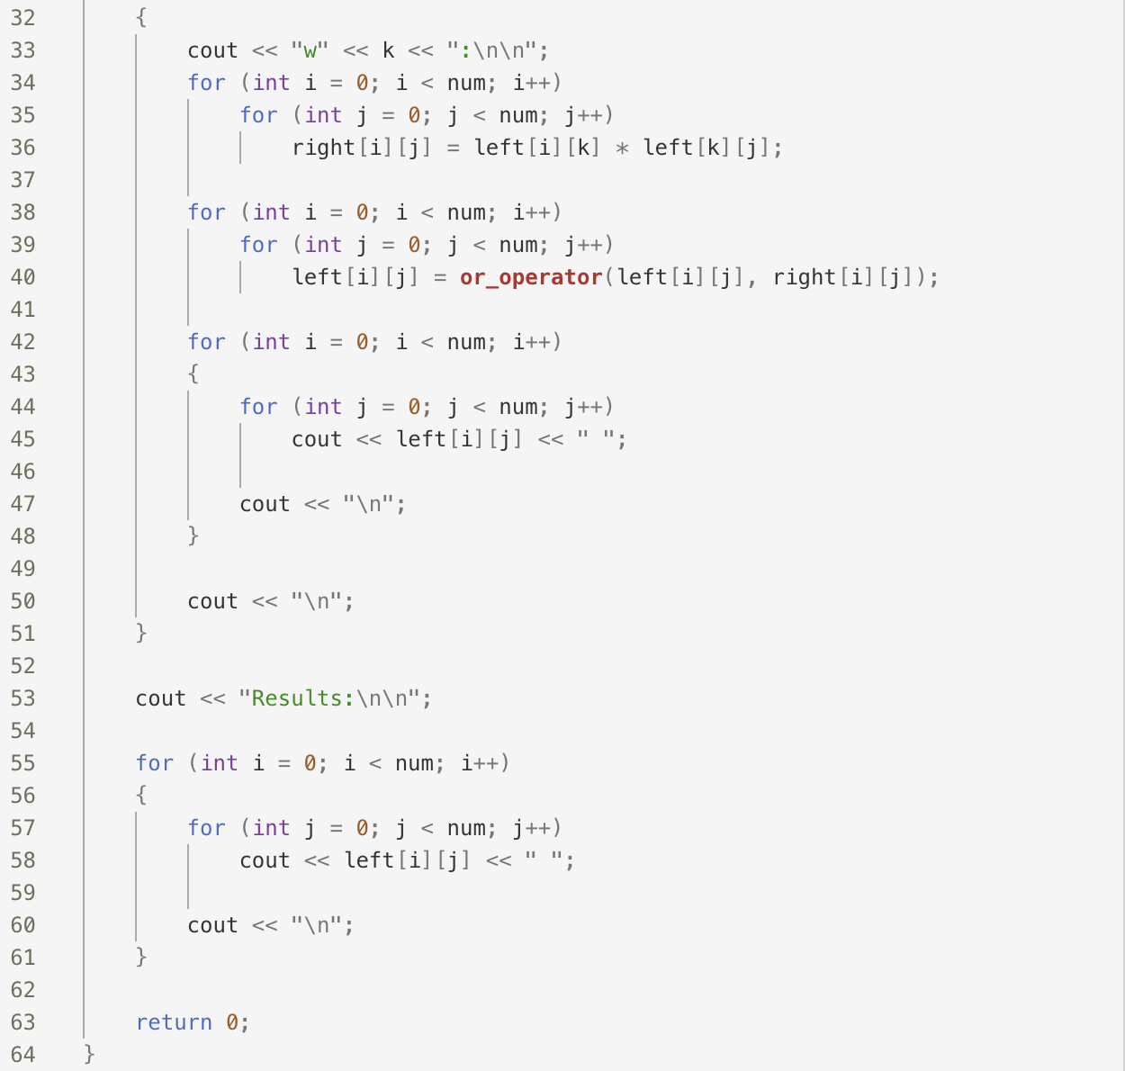

Here, $B=\left[\begin{matrix}1 & 1 & 1 & 1 & 1 \\ 1 & 1 & 1 & 1 & 1 \\ 1 & 1 & 1 & 1 & 1 \\ 1 & 1 & 1 & 1 & 1 \\ 1 & 1 & 1 & 1 & 1\end{matrix}\right]$.

# Section 9.5

1. Determine whether the relations represented by these zero-one matrices are equivalence relations:

$\left[\begin{matrix}1 & 1 & 1 \\ 0 & 1 & 1 \\ 1 & 1 & 1\end{matrix}\right]$

It’s reflexive.

It’s not symmetric because $\left(1,2\right)∈R$ but $\left(2,1\right)∉R$.

Thus, this relation is not an equivalence relation.

$\left[\begin{matrix}\begin{matrix}1 & 0 \\ 0 & 1\end{matrix} & \begin{matrix}1 & 0 \\ 0 & 1\end{matrix} \\ \begin{matrix}1 & 0 \\ 0 & 1\end{matrix} & \begin{matrix}1 & 0 \\ 0 & 1\end{matrix}\end{matrix}\right]$

It’s reflexive.

It’s symmetric.

In this relation, for some relation $\left(x,y\right)∈R$, $x$ and $y$ are both odd or both even. Because this holds for all relations, every odd value is related to every other odd value and every even value is related to every other even value. That is, $a$, $b$, and $c$ are all odd or even and $\left(a,b\right)∈R∧\left(b,c\right)∈R→\left(a,c\right)∈R$. Thus, this relation is transitive.

Because this relation is reflexive, symmetric, and transitive, it is an equivalence relation.

1. Which of these are partitions of the set of real numbers?
   * The set of intervals $\left[k, k+1\right]$, $k∈Z$

This is not a partition. Every integer is included twice.

* + The set of intervals $\left(k, k+1\right]$, $k∈Z$

This is a partition. We have the same sets as in part a, but the integers are not included twice in the sets.

* + The sets $\left\{x+n \right| n∈Z\}$ for all $x∈[0, 1)$

This is a partition. Because $x$ is unique, and because $n$ is an integer, $x+n=n.x$ is unique for all

$x∈[0,1)$.

# Section 10.2

1. Complete the following proof that, in a simple graph with at least two vertices, there must be two vertices that have the same degree.

Proof: Let $G=(V,E)$ be a simple graph with $\left|V\right|=k≥2$. Then every vertex $v_{i}∈V$ has $\deg{(v_{i})}∈D=\{0,1,2,…,k-1\}$. Assume no two vertices have the same degree. Then, because $\left|D\right|=k=|V|$, there is exactly one vertex $v_{i}∈V$ having each degree $d_{i}∈D$. Without loss of generality, let each $v_{i}∈V$ have $\deg\left(v_{i}\right)=i$. Since

Because of the extra credit, I’m leaving this problem blank.

# Section 10.3

1. Suppose that $G$ and $H$ are isomorphic simple graphs. Complete the following proof that their complementary graphs $\overline{G}$ and $\overline{H}$ are also isomorphic.

Proof: Let $G=(V_{G},E_{G})$ and $H=(V_{H},E_{H})$ be isomorphic simple graphs. Then there exists a one-to-one and onto function $f$ from $V_{G}$ to $V_{H}$ with the property that $a$ and $b$ are adjacent in $G$ if and only if $f(a)$ and $f(b)$ are adjacent in $H$, for all $a$ and $b$ in $V_{G}$. Suppose $a$ and $b$ are adjacent in $\overline{G}=(V_{G},\overline{E_{G}})$.

Because of the extra credit, I’m leaving this problem blank.

**Note: If class is canceled on December 5, then the following problems become extra credit.**

# Section 10.4

1. Show that, if $G$ is a connected graph with $n$ vertices, then $κ(G)=n-1$ if and only if $G=K_{n}$.

It is impossible to show this. If $G=K_{n}$, each of the $n$ nodes is necessarily connected to each of the other $n-1$ nodes. This indicates that no two nodes can be colored with the same color, so the chromatic number of a graph $G=K_{n}$ must be $n$. That is, $G=K_{n}→κ\left(G\right)=n≠n-1$.

# Section 10.5

1. For which values of $m$ and $n$ does the complete bipartite graph $K_{m,n}$ have an
   * Euler circuit?

$K_{m,n}$ has an Euler circuit if and only if both $m$ and $n$ are even.

* + Euler path?

$K_{m,n}$ has an Euler path if and only if $m=2$ and $n$ is odd or $n=2$ and $m$ is odd.

# Section 10.6

1. Explain how to find a path with the least number of edges between two vertices in an undirected graph by considering it as a shortest path problem in a weighted graph.

We can effectively use Dijkstra’s algorithm to solve this problem. Instead of greedily selecting the lowest-weight path, though, we’ll greedily select the path with the least number of edges. That is, instead of selecting the next node $u$ if $u$ has the minimum total path weight of all unexplored nodes, we select $u$ if there are fewer edges to $u$ than to any other explored node. In making this modification, we ensure we only add a new node $v$ to our explored set if we’ve found the path to $v$ with the least number of edges. This guarantees we can reach the destination by way of the path with the least number of edges.

# Section 10.8

1. Complete the following proof that a simple graph that has a circuit with an odd number of vertices in it cannot be colored using two colors.

Proof: Let $v_{0},v_{1},…,v_{n},v_{0}$ be a circuit in a simple graph $G$ and suppose that $G$ can be colored using two colors. Without loss of generality, assume that $v_{0}$ is colored Air Force Blue (RGB #00308F). Then, because it is adjacent to $v_{0}$, $v_{1}$ must be colored with the other color, say Air Superiority Blue (RGB #72A0C1). Furthermore, by induction, $v_{i}$ must be colored Air Force Blue if $i$ is even and Air Superiority Blue if $i$ is odd. This extends to $v_{n}$ (that is, $v_{n}$ must be colored Air Force Blue if $n$ is even and Air Superiority Blue if $n$ is odd). Because our circuit consists of an odd number of vertices, $n$ is even (because we started with $0$) and $v_{n}$ is colored Air Force Blue.

Because both $v_{n}$ and $v_{0}$ are colored Air Force Blue, and because they are necessarily adjacent in the circuit, we cannot color the circuit with two colors. Because we cannot color the circuit with two colors (that is, we cannot color a subgraph of $G$ with two colors), we know we cannot color $G$ with two colors.